University of Canberra
Faculty of Science and Technology

Software Technology 2
(7170)
Week 6 Tutorial & Computer Lab

Assignment 1: Individual Project
Part 3: Linear Data Structures (Linked Lists, Stacks, Queues and Priority Queues)

Task 1: Linked Lists, Stacks, Queues, and Priority Queues
- Run the script linked_lists_practice.py for testing the simple python lists, single linked and double linked list data structure code and benchmark their performance for different data sizes. Report on the performance (screenshots)for each data size. Currently it is set for 1000. Test it for 10000 and 50000.
Data size: 10000
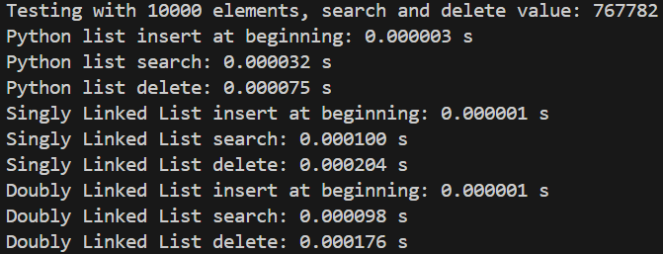

Data size: 50000
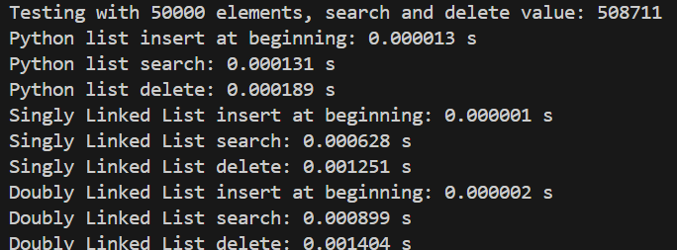

- Run the script stacks_queues_practice.py for testing the stack, queue and priority queue datastructure code and double linked list code and comparing their performance for different data sizes. Report on the performance (screenshots) for each data size. Currently it is set for 1000. Test it for 10000 and 100000.

Data size: 10000
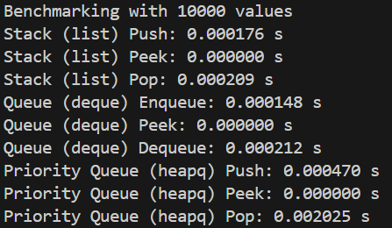

Data size: 100000
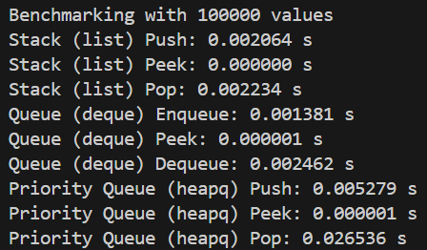

Task 2: Visualising Linked Lists
- The python script double_linked_list_visualiser.py allows visualisation of search, insertion and delection in a double linked list (dll). A successful test execution of this script should display the following GUI interface:

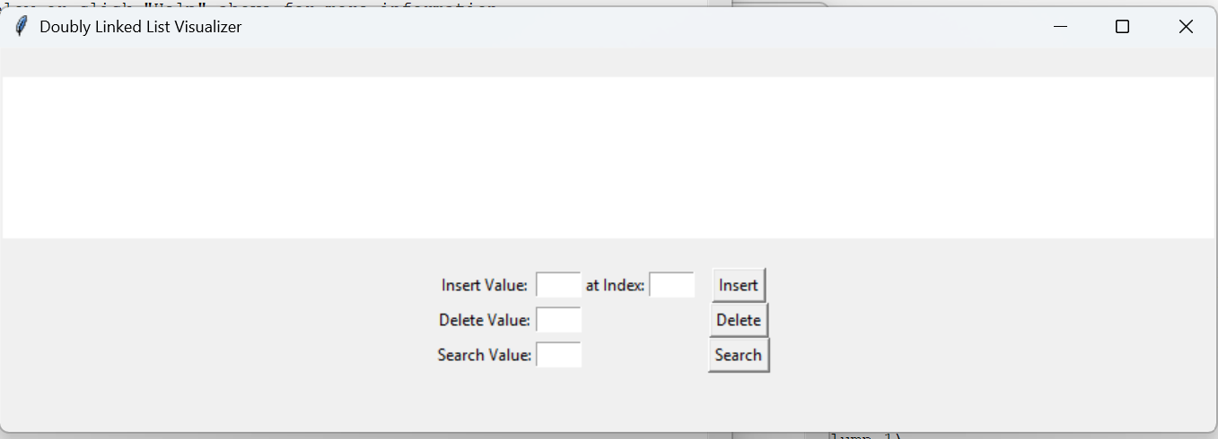

- Test the code for inserting a list of integers (10,20,30, 40.50), and report the results (screenshots) for visualising insertion, search and deletion operations.
  - Test results (screenshots) when the Insert button inserts the value into the specified index in the dll list.
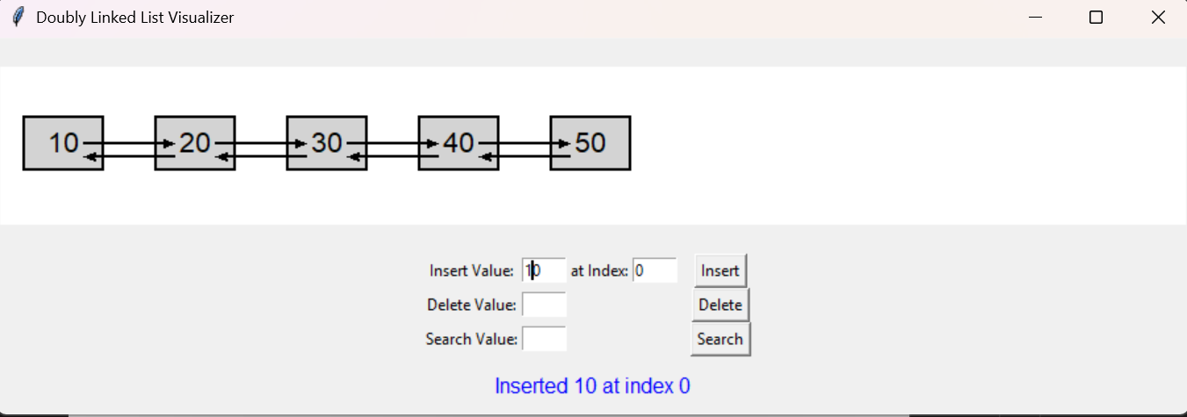

  - Test results when the Search button searches whether the specified value is in the dll list.
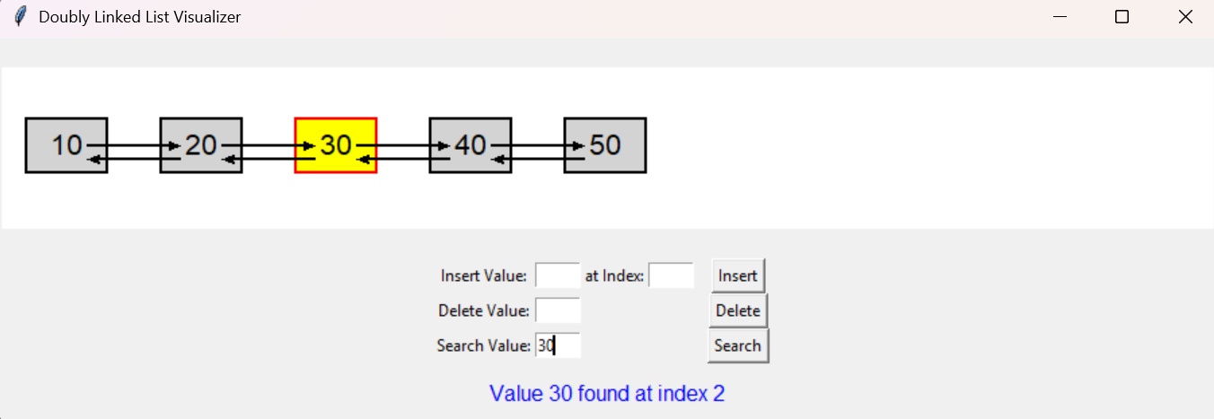

  - Test results when the Delete button deletes the specified value from the dll list.
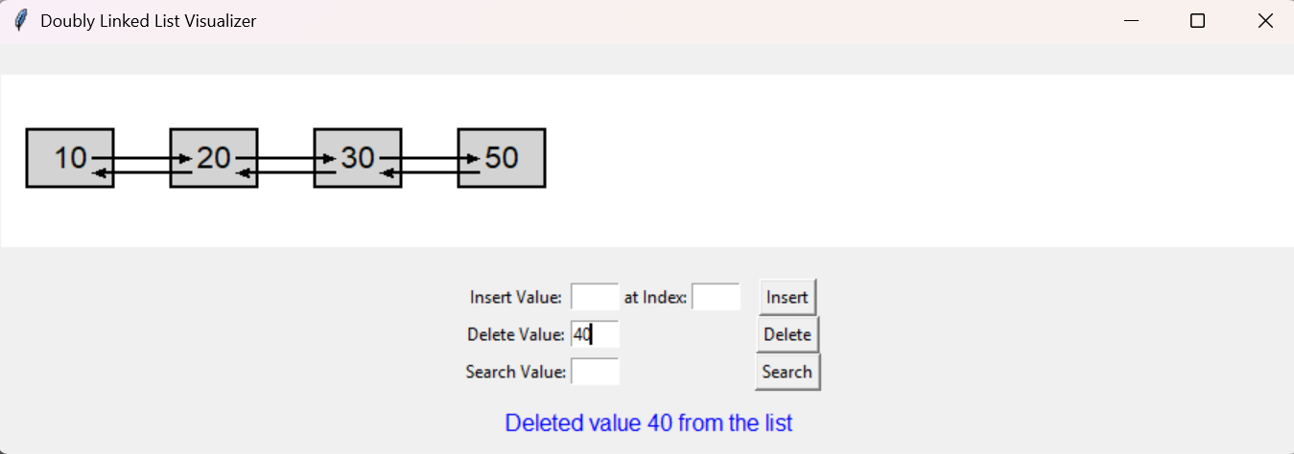

  - Modify the visualiser code for this task to allow visualisation of single linked list. You can use the relevant classes from Task 1 related to single linked lists to write this single linked list visualiser.
  - Show the GUI layout of a successful test run for this script.
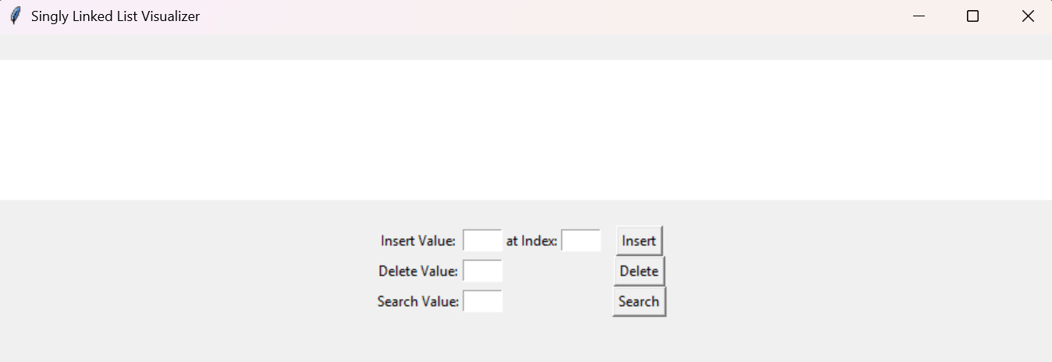

  - Submit the code as single_linked_list_visualiser.py
  - Show the results (screenshots) for insert, search and delete button operations (same test data - list of integers (10,20,30, 40.50) )

  - Test results when the Insert button inserts the value into the specified index in the sll list.
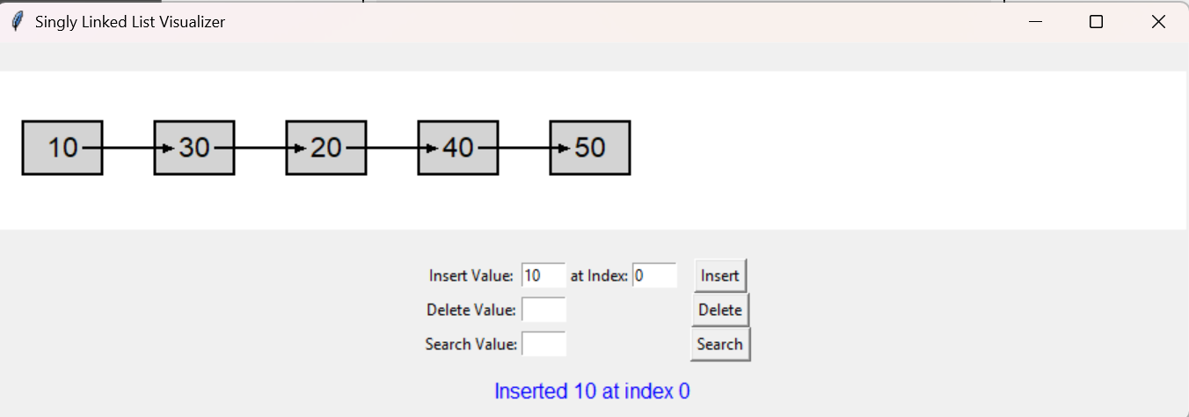

  - Test results when the Search button searches whether the specified value is in the sll list.
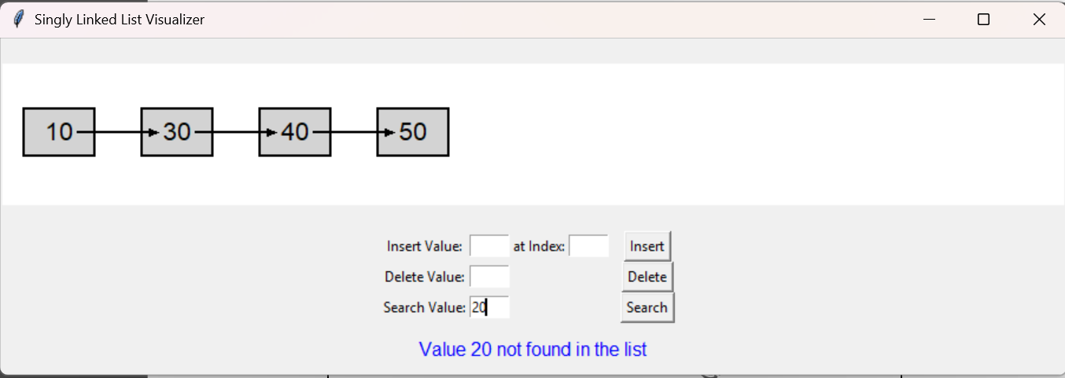

  - Test results when the Delete button deletes the specified value from the sll list.
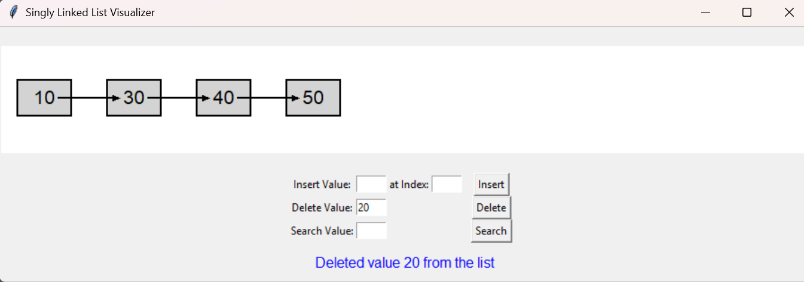

Task 3: Visualising Stacks and Queues
- The python script stack_visualiser.py allows visualisation of LIFO push and pop operations for stack data structure. A successful test run of the code show display the following:
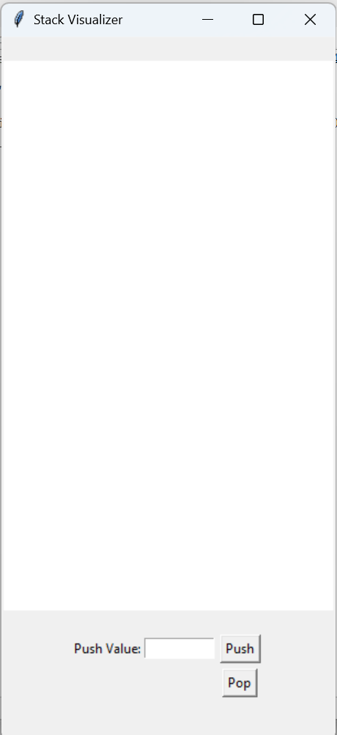
Test the visualiser for pushing a list of integers [10,20,30,40,50] and popping the list. Show the results (screenshots) of how the push and pop operations for a stack are performed in a LIFO order.
  - Test results when the Push button inserts the value in the stack
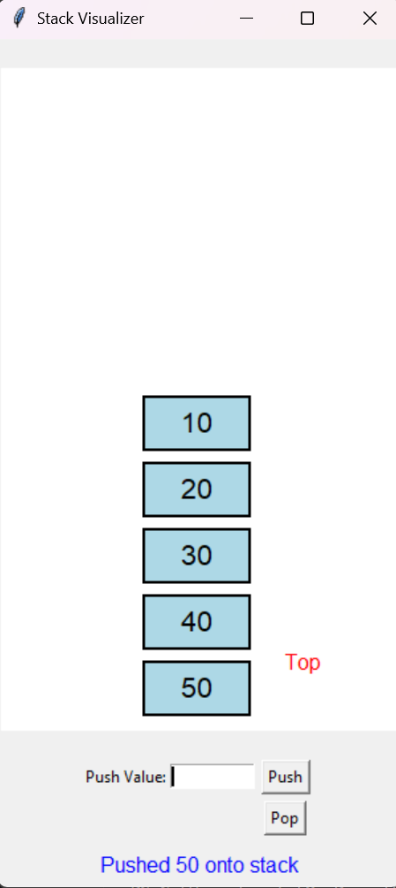

  - Test results when the Pop button retrieves value from the stack.
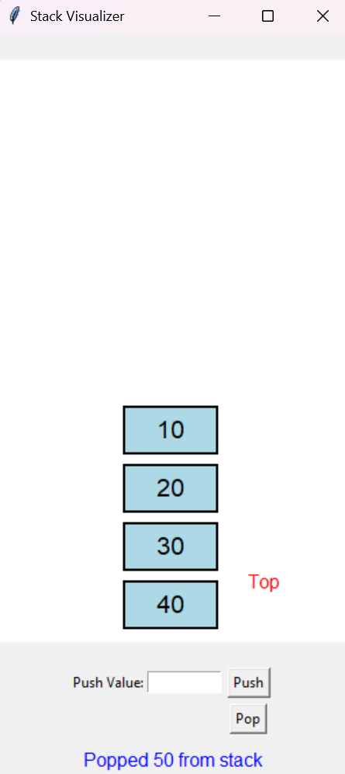
  - Modify the visualiser code for this task to allow visualisation of queue . You can use the relevant classes from Task 2 related to queues to write this queue visualiser.
  - Show the GUI layout of a successful test run for this script.
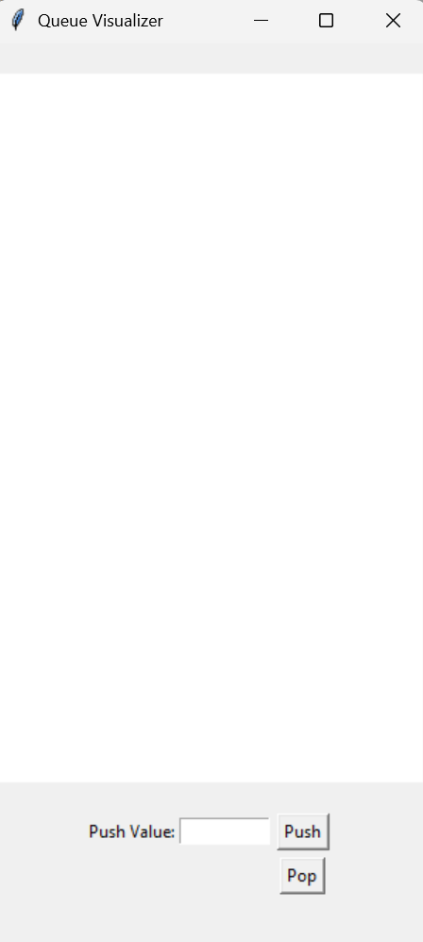

  - Submit the code as queue_visualiser.py

  - Show the results (screenshots) for push and pop button operations (same test data - list of integers (10,20,30, 40.50) )
  - Test results when the push button inserts the value into the queue.
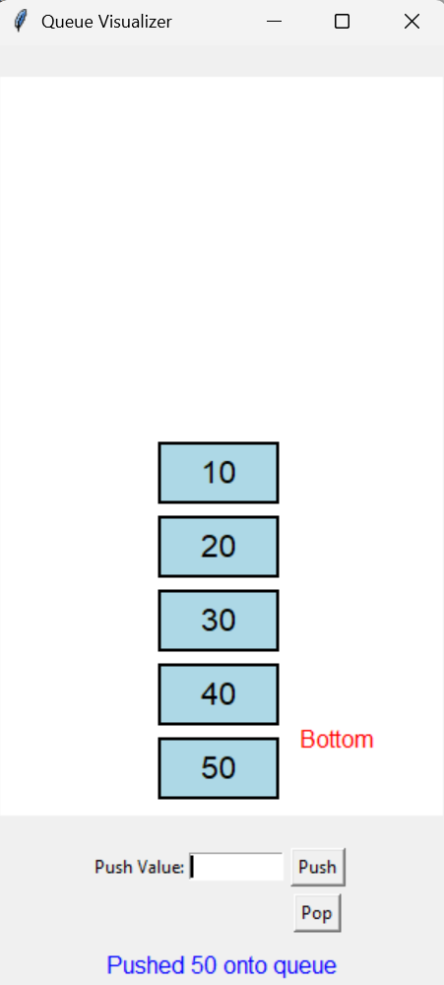

  - Test results when the pop button retrieves the specified value from the queue.
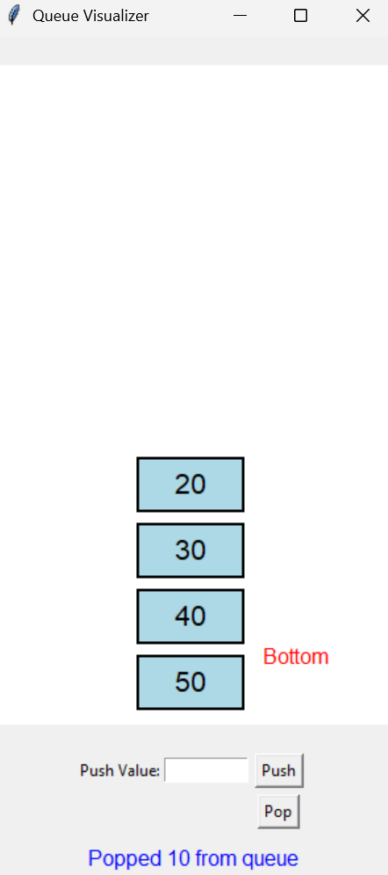

Task 4: Visualising Priority Queues
- The python script priority_queue_visualiser.py allows visualisation of FIFO push and pop operations for priority queue data structure. A successful test run of the code show display the following:
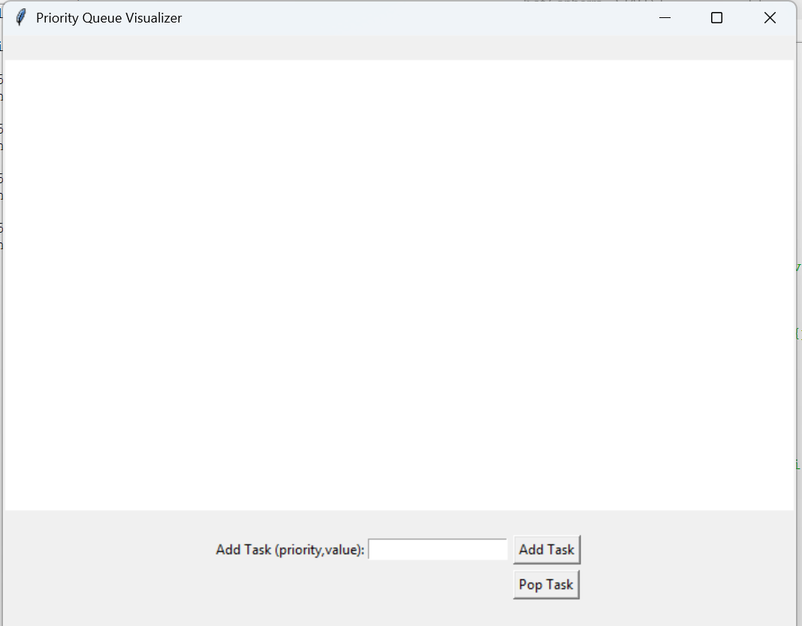

Test the visualiser for pushing a sequence of tasks with priority in terms of priority and value.
For example (1, Eat), (2,Sleep), (3, Work). Show the results (screenshots) of how the push and pop operations for a priority are performed in FIFO, but based on priority assigned.
  - Test results when the Add Task button is used to insert tasks with priority value
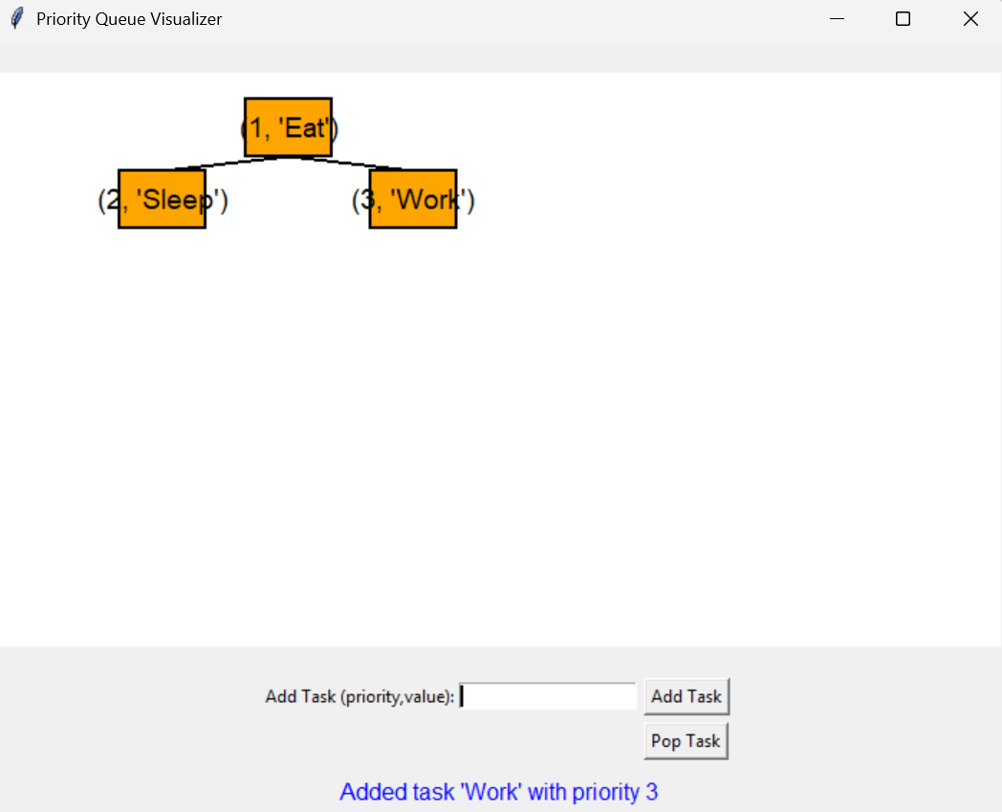

  - Test results when the Pop Task button retrieves value from the stack.
